I2C Display Backpack

Stuart Robinson

www.LoRaTracker.uk

A feature of my tracker programs is that even the small tracker boards themselves can be used as receivers and drive displays.

For Arduino based projects using low cost components such as the Pro Mini a display can consume significant amounts of the available resources in the form of memory or I\O pins. Upgrading from say a Pro Mini based board to a ATmega2560 board is often not an option.

However, board space is at a premium for the small boards so its not that practical to provide for the 8 pins that a Nokia 5110 or ILI9341 display requires. For these boards the I2C based SD1306 and 20x4 LCD displays are a good choice.

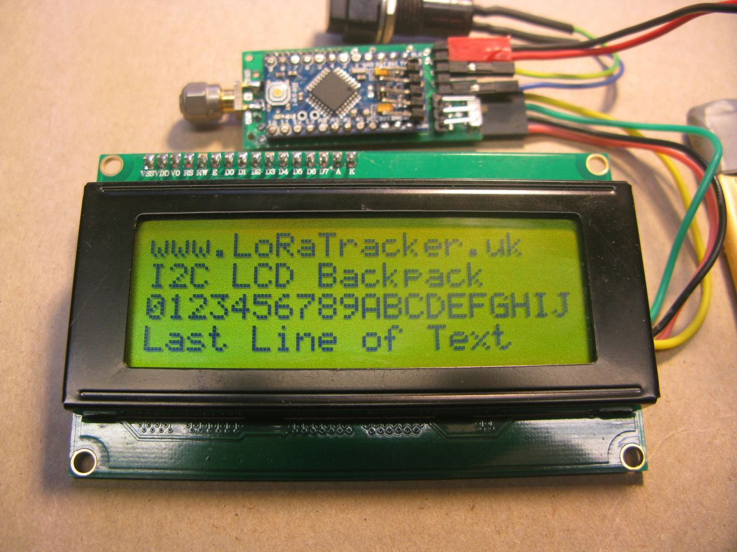
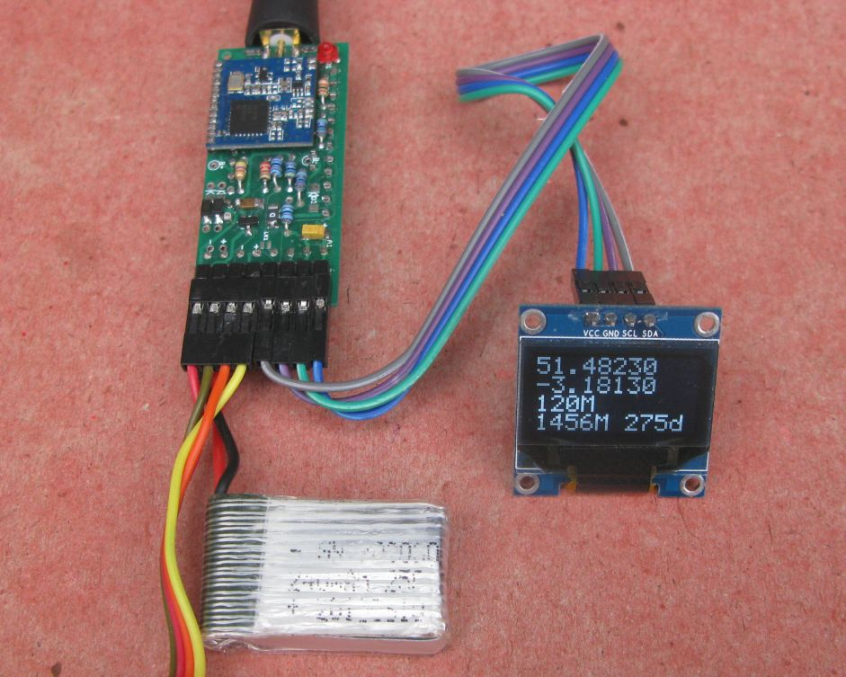

A display backpack PCB was designed to overcome some of the problems of using for using the Nokia 5110 and ILI9341 displays by offloading the software and I\O pin requirement from the project itself onto a backpack PCB fitted to the display itself. The backup PCB uses a low cost Pro Mini (3.3V) as its processor, driven by a single serial pin.

The commands to drive the display backpack followed the serial format used by Digole. An Arduino program to drive the display in this format would look like this;

disp.print("CL"); //clear display
disp.print("TP"); //position cursor command
disp.write(col); //column
disp.write(row); //row
disp.print(“TTHello World ");
disp.write(13);

Digole use that format for driving most of their displays, so with one common software interface you have the choice of multiple displays. There is nothing wrong with the above format, but when using it its not really clear what you are doing, its not obvious that “TP” is the cursor position command. If you define byte values such as ‘CursorPosition’ and ‘StartText’ and use these to control the display the above program snippet looks like this;

disp.write(ClearDisplay); //clear display
disp.write(CursorPosition); //position cursor command
disp.write(col); //column
disp.write(row); //row
disp.write(StartText); //start text
disp.print(“Hello World "); //put text on display
disp.write(EndText); //end of text

Which is easier to understand.

Driving the display like this over a serial connection certainly works, but it was not exactly fast. Some of the speed issues are related to the Pro Mini, the 3.3V versions run at 8Mhz, and for displays such as the ILI9341 a screen clear can take a second or more, the processor does have to set each pixel to the background colour. For this reason the serial backpack I had restricted to text only.

Which got me thinking, why not use the backpack technique to provide an I2C connected display, most of my tracker boards use I2C already and have connectors for I2C sensors and similar, the I2C interface ought to be faster.

It would also be useful to have my tracker programs using a common set of display routines so that swapping displays to whatever type takes your fancy would just need a different program on the backpack.

I first listed the minimum of commands needed to run a text based display. The idea was that a command to the display would be an I2C communication that would start by sending a byte that identifies what the command is, and then send the actual data. It would also make sense to adopt the same commands to control a backpack over a serial interface.

This is the list of commands and the bytes that identify them;

Display Functions – Text Display

Function Number Character
ClearDisplay = 0x43; 'C'
CursorPosition = 0x50; 'P'
StartText = 0x54; 'T'
FontScale = 0x53; 'S'
UpdateDisplay = 0x55; 'U'
FontStyle = 0x46; 'F'
DisplayRotation = 0x52; 'R'
InitialiseDisplay = 0x49; 'I'
TextColour = 0x31; '1'
BackgroundColour = 0x32; '2'
ClearRow = 0x33; '3'
Contrast = 0x34; '4'

Text characters were chosen for defining the commands, as it would be easier to remember and when looking at a stream of text between project driver and display you can more easily see what was happening. Not all displays need support all options, any commands sent that are not valid or are appropriate for the particular display are ignored.

Colours

For displays that support colours, the following list of basic colours has been defined;

Black = 0x00;
Blue = 0x01;
Red = 0x02;
Magenta = 0x03;
Green = 0x04;
Cyan = 0x05;
Yellow = 0x06;
White = 0x07;

The list of definitions is in this file in the LoRaTracker library;

I2CDisplay_Definitions.h

If the above command set is adopted, with Arduino if we want to print text on the display we could use this snippet of program;

Wire.beginTransmission(DisplayAddress); //use I2C address of display
Wire.write(StartText);
Wire.write("Hello");
Wire.endTransmission();

Or we could do this;

Wire.beginTransmission(DisplayAddress); //use I2C address of display
Wire.write('T');
Wire.write("Hello");
Wire.endTransmission();

An EndText marker is not really required, we can tell when the I2C transmission has explicit ended.

If we want to position the cursor at column 5, row 2 we do this;

Wire.beginTransmission(DisplayAddress);
Wire.write(CursorPosition);
Wire.write(5);
Wire.write(2);
Wire.endTransmission();

or this;

Wire.beginTransmission(DisplayAddress);
Wire.write('P');
Wire.write(5);
Wire.write(2);
Wire.endTransmission();

This list of commands can be used on any micro controller that supports I2C, here is the equivalent of the above cursor position in Micro Python on a micro:bit;

i2c.write(display_address, b'CursorPosition,5,2')
i2c.write(display_address, b'\x23\Hello World1')

Since the I2C interface is two way, you could also arrange for the backpack to report back to the controlling program that the display is busy being updated or cleared for instance.

In the case of the Arduino a class library has been written such that once the display is initialised, as ‘disp’ in the snippet below the driving program can write to the display in an easy to understand way;

I2CDisplay disp(Display_Address); //create the display class

disp.clear();
disp.setcursor(5,2);
disp.print(“Hello”);

I principle it should be possible to write an application, using the I2CDisplay class library that will run on whatever display is connected to the display backpack.

ILI9341 Display

This is a 320 x 280 pixel display that isused as a text display with 8 text and background colour chocies.

The display will show text in scales from 1 to 4. The font is the SystemFont5x7. With the display in landscape mode, long edge horizontal, the rows and columns you can display in each text scale are;

1 - 24 Rows, 54 Columns
2 - 12 Rows, 26 Columns
3 - 8 Rows, 18 Columns
5 - 5 Rows, 13 Columns

You will need to download and install the following library, yes I know it looks like its for Arduino DUE, byt it works on AVRs too and is about twice as fast in a screen clear;

https://github.com/marekburiak/ILI9341_due.

You can set the text colour using the 'TextColour' command and the background colour using the 'BackgroundColour' command. The colours you can use are, Black, Blue, Red, Magenta, Green, Cyan, Yellow, White. You use the colours either by giving the colour command the constant name for the colour or the nummber associated with it, see the list of colours listed above.

For instance to set the text colour to red in Arduino do this;

Wire.beginTransmission(DisplayAddress);
Wire.write(TextColour);
Wire.write(Red);
Wire.endTransmission();

Display Rotation

For the LoRaTracker programs the display is normally used in rotation 1, to provide for the longest lines of text. Rotation is from 0 to 3, 0 being the tall thin rotation.

Nokia 5110 Display

These are small LCD screens re-cyled from old mobile phones mainly. Quality can be variable. The only support 6 rowsor 13 characters, but are small,low cost, low power and ideal for use in bright sunshine.

The driver file for the I2C backpack is;

Nokia5110_I2C_Backpack_141217.ino

It uses the Adafruit libraries which you need to download and install;

Adafruit_GFX.h //https://github.com/adafruit/Adafruit-GFX-Library
Adafruit_PCD8544.h //https://github.com/adafruit/Adafruit-PCD8544-Nokia-5110-LCD-library

Two Font sizes are supported 1 and 2 which are 6 rows x 13 characters and 3 rows by 6 characters respectivly. When writing to the display the characters are first written to a buffer in the 5110 and to actually display them on the screen you need to send an 'UpdateDisplay' command. See the test example.

Also note that if you do not clear the screen first then any text you write will appear over the top of previous text. So at the start of a screen write clear the screen first, this is quick taking around 20mS.

Stuart Robinson
www.LoRaTracker.uk
December 2017

